Name:_________________________

**Turning on the LEDs - MakeCode**

**What you need:**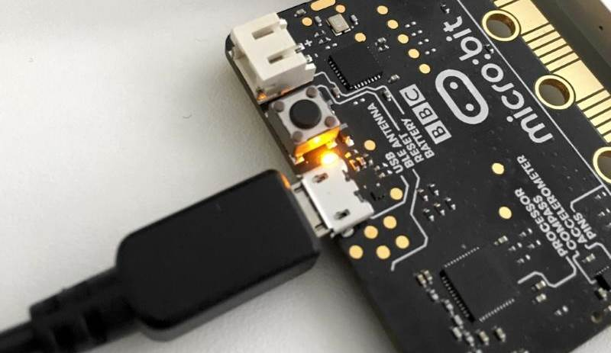

1. A computer with a USB port
2. V2.0 micro:bit
3. USB cable

**Setup:**

1. Plug in your micro:bit with the USB cable. The small USB mircoB end goes to the micro:bit and the regular USB end goes to the computer.
2. In a browser, go to <https://makecode.microbit.org/>. This is where you will program your micro:bit.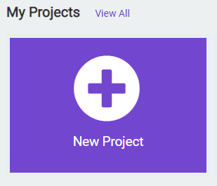
3. Click on ‘New Project’
4. You can name your project whatever you want, but you should name it based on the title of the lab. In this case, ‘Turning on the LEDs’’

**Instructions:**

1. To start, we will work in the **forever** code block. This block will continuously execute the code that we put inside this block. To turn on an LED, click on **Led** tab on the left hand side of the screen: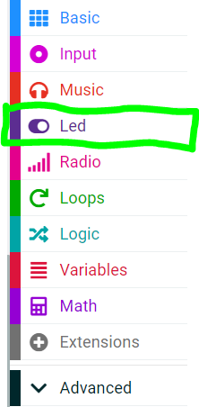
2. We want to use the **plot** code block from the menu. The coordinates in this code block are related to each LED on the micro:bit screen. In this case, the default (0,0) position is the top left hand corner. Click and drag it to the **forever** code block: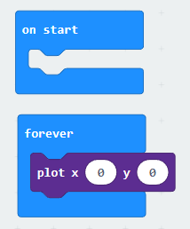
3. Click the **Download** button on the bottom on the bottom left hand side of the screen. This will upload your program to the micro:bit. You should be able to see the top left hand LED turn on!

**You Try It!**

Experiment with the **ploy** code block. Can you make a different LED light up? Can you make more than one LED turn on?